- Connect SQL Server Container
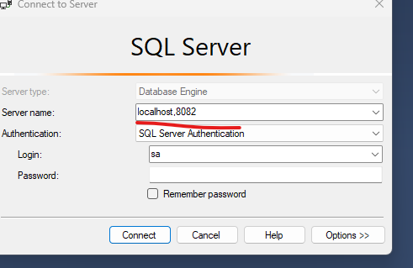
Using command(,) instead use ‘:’

